|  |  |  |
| --- | --- | --- |
|  |  |  |
|  |  |  |
| ROI Toolkit & Benefits Letter  HiSET Roadshow Boston 2025 | | |
|  | | |
|  | | |

# Letter for Your Supervisor

**Subject:** Request to Attend the 2025 HiSET Roadshow in Boston, MA

**Dear [Supervisor’s Name],**

I would like to request approval to attend the **2025 HiSET Roadshow**, taking place at **Boston University on October 6–7, 2025**. The HiSET Roadshow is open to adult educators, test center staff, HSE advocates, and adult ed/HSE/workforce development state staff. It presents a valuable opportunity for professional development and collaboration aligned with our mission to support adult learners and advance HSE outcomes.

Key Benefits to Our Program:

**1. Targeted Training for Adult Education & Test Center Staff**  
The half-day **Pre-Conference Training** (October 6, 1:00–5:00 PM) focuses on the roles and responsibilities of Test Center Administrators, Adult Educators and workforce development state staff. The hands-on sessions will provide new tools and best practices I can immediately apply in our work.

**2. Up-to-Date Information & Resources**  
During the full-day conference (October 7, 8:00 AM–4:00 PM), I’ll receive key updates on HiSET policies, exam developments, and preparation materials. This knowledge will help ensure our team remains aligned with best practices current policies and procedures, and delivers the highest quality support to students.

**3. Peer Networking & Collaboration**  
The Roadshow brings together professionals from across the region, offering a rare chance to network, share strategies, and build partnerships that can enhance our local HiSET implementation.

**4. Unique Experience to Gain Insight on HSE in Other States**  
Attending this event will offer a broader perspective on how different states approach high school equivalency. Learning about the unique challenges they face—such as funding models, legislative hurdles, or access disparities—along with the creative solutions they've implemented, will be incredibly valuable. It’s also a great opportunity to gather tips on effective advocacy and lobbying strategies that have worked in other regions. These insights can help inform our own program planning and outreach efforts.

**5. Direct Access to HiSET Experts**  
The event includes dedicated Q&A sessions where attendees can engage with the HiSET team to get answers and clarity on program questions and challenges.

**6. Recognition & Motivation**  
The event celebrates accomplishments from within the HiSET community—an important opportunity to reflect on what’s working and bring that energy back to our own team.

**7. Workforce**   
It presents a valuable opportunity for professional development and collaboration aligned with our mission to support adult learners, advance HSE outcomes, and inform workforce pathways.

I believe that attending this event is a valuable investment in our program and professional growth. I would be happy to share what I learn through a follow-up presentation or resource guide for the team.

Thank you for your time and consideration.

**Sincerely,**  
[Your Name]  
[Your Title/Organization]  
[Contact Information]

# Benefits Worksheet

Use this worksheet to list the benefits you will bring to your company by attending HiSET Roadshow in Boston, MA in person. In the following table, replace the *italicized text* in the examples section with the content sessions you plan to attend or other opportunities that can help you enhance your skills as a professional and face the challenges of your industry.

|  |  |
| --- | --- |
| **Benefit to [Name of Organization]** | **Examples** |
| Staying current with HSE and HiSET program updates |  |
| |  | | --- | | Learning best practices in adult education and test center operations | | |  | | --- | | Sessions to attend:  *● XXXXXX*  *● XXXXXX* | |
| |  | | --- | | Understanding available HiSET preparation materials and resources | | |  | | --- | | Sessions to attend:  *● XXXXXX*  *● XXXXXX* | |
| |  | | --- | | Exploring how to better support diverse student populations | | |  | | --- | | Sessions to attend:  *● XXXXXX*  *● XXXXXX* | |
| |  | | --- | | Hearing about evolving learner needs and the future of equivalency testing | | |  | | --- | | Sessions to attend:  *● XXXXXX*  *● XXXXXX* | |
| |  | | --- | | Sharing knowledge and tools with colleagues post-event | | |  | | --- | | **I commit to:** ● A team debrief and short presentation ● Sharing literature and slide decks from sessions ● Applying strategies to improve our HiSET outcomes ● Ongoing communication with Roadshow contacts and partners | |

We have also provided a table that can be used from a broader perspective, if you are filling this out prior to the full programme being published (expected in late August 2025).

|  |  |  |
| --- | --- | --- |
| Topics Covered | Focus of Sessions | Plan for using this to grow as a professional and educate |
| |  | | --- | | Candidate Experience | | |  | | --- | | Sessions will highlight how HiSET programs can better support learners by improving accessibility, personalizing instruction, and addressing barriers to testing and credential attainment. | |  |
| |  | | --- | | HiSET Program Innovation | | |  | | --- | | Presentations will introduce new tools, prep resources, instructional approaches, and delivery methods aimed at improving HiSET outcomes and making the test process more effective for educators and students. | |  |
| |  | | --- | | Collaboration & Community Building | | |  | | --- | | The event will emphasize connection across roles—state leaders, educators, test center administrators—and encourage open exchange of ideas, challenges, and solutions for improving HSE programs regionally. | |  |

# Estimated Expense Worksheet

Use this worksheet to list the estimated expenses you plan to incur by attending the 2025 HiSET Roadshow, Boston, MA. In the following table, insert your estimated amount for each item in the cost column.

#### HiSET Roadshow Conference Estimated Expenses

|  |  |  |
| --- | --- | --- |
| **Attendee** | **Insert Name Here:** | **Date:** |
| **Expense** | **Information** | **Cost** |
| |  | | --- | | Registration Fee | | |  | | --- | | Check to determine if you qualify for early bird booking or standard | | [insert amount] |
| Flight | |  | | --- | | Use the Internet for an estimate, you may also want to add in baggage fees | | [insert amount] |
| Hotel | Various options please check best one. | [insert amount] |
| Transport from hotel to airport and back | |  | | --- | | Cost will vary depending on the day and company used | | [insert amount] |
| Mileage Reimbursement | |  | | --- | | Are you driving to the conference? Or do you need to take your vehicle to the airport? | | [insert amount] |
| Parking | |  | | --- | | Do you need to park your car at an airport while you are at HiSET Roadshow Conference? Are you driving and need to park your car at the hotel? | | $12.00 per day at Boston University |
| Miscellaneous | |  | | --- | | Are there any other expenses associated with attending the conference? | | [insert amount] |
| **Total** |  | **$** |

Transport: 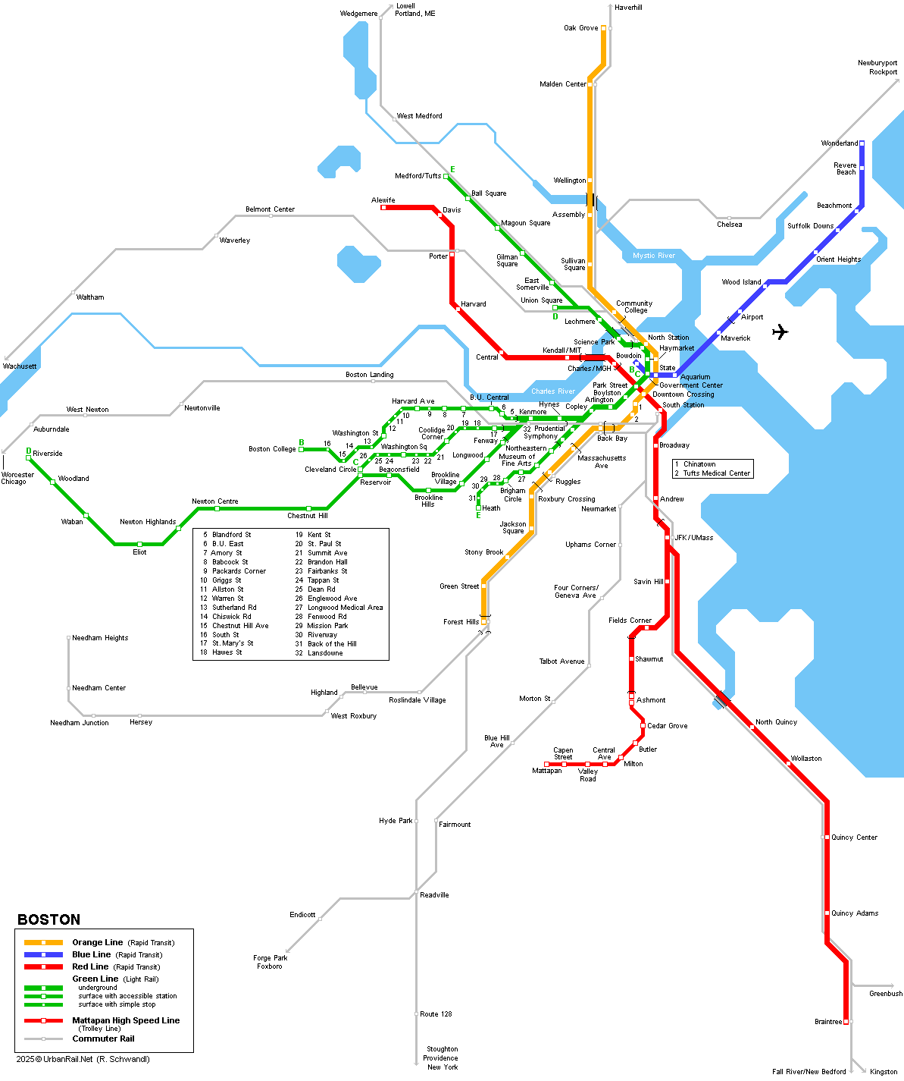

**Location:**

[**43 Hawes Street**](https://maps.bu.edu/?id=647#!m/361880)  
Brookline, MA 02446

43 Hawes Street, also known as the **Wightman Mansion**, is a beautiful, historical mansion. The mansion is located near the **Boston University Fenway Campus** in charming Brookline.